Enhancing Cloud Security through Machine Learning Driven Threat Detection and DevSecOps Integration

Josh Hernandez
CYBV 579: Cloud Security
Professor Alharthi
March 04, 2026

Abstract
Modern day cloud-based infrastructure systems require sophisticated security systems due to advanced network requirements, global connectivity needs, and susceptibility to attacks which can affect the widespread availability of services. Distributed technological systems in a remote setting, such as the cloud, require advanced setup procedures and thoughtful implementation of supporting software applications to achieve an optimal balance. Machine learning, a subset of Artificial Intelligence, is quickly revolutionizing cybersecurity and software systems alike at a prolific rate. Through an experimental approach, this paper examines how cloud security can be strengthened through machine learning driven threat detection and DevSecOps practices. Effectively and securely launching a cloud-based software system can be an incredibly complex task due to the intricate architecture of these systems, but adhering to simple principles of security and operational knowledge can strengthen the resiliency of these networks. This paper also serves the benefit of providing a beginning roadmap and understanding of entry level cloud security principles and operations that could benefit a new startup or enterprise cloud operation.

Keywords: cloud security, machine learning, DevSecOps, AI-driven threat detection, cloud providers, cloud penetration testing

Enhancing Cloud Security through Machine Learning Driven Threat Detection and DevSecOps Integration
The future of computing requires innovative and intelligent solutions that combine the technological advancements from cutting-edge research and the analysis of current and past implementations. Cybersecurity is at the forefront of securing our most essential technological systems that power critical industries consumers utilize everyday including but not limited to finance, health care, science, education, government, cyber-physical energy systems, and retail. Historically, organizations have operated at singular locations without large-scale connectivity amongst software systems, applications, and networks. Recent industry demands and the prolific expansion of software systems globally have necessitated the creation of cloud-based infrastructure which provides businesses the ability to connect and integrate software systems remotely without the requirement of large physical computing and data centers. Cloud Security is a critical subdomain of cybersecurity which addresses the protection of these widespread, digital infrastructures and secures the reliability and integrity of these systems for both consumers and organizations alike.
Regardless of the industry type, cloud-based software must have the capability to be instantaneously deployed, support expanding systems, large scale big data operations, and high intensity computing applications in a network based digital setting. Organizations that operate these systems have the responsibility to provide the confidentiality, integrity, and accessibility of their consumer data. To address these unique challenges, the field of cybersecurity has integrated Artificial Intelligence based security systems that automate threat detection capabilities and centralize security operations. Machine Learning, a subset of Artificial Intelligence, is the core technology that powers these sophisticated security solutions and addresses the unique challenges of a cloud-based infrastructure. AI-powered security systems can protect a cloud-based system on many fronts, including identifying security anomalies through intelligent threat detection, providing automated security alerts, continuously monitoring critical systems, and even identifying internal software misconfigurations.
Cloud security requires a well-rounded approach that not only monitors suspicious or threatening activity and provides automated alerts, but that considers the vulnerabilities of a system’s digital assets. DevSecOps is a security engineering discipline that emphasizes secure software development and frequent system testing to identify vulnerabilities throughout the software development lifecycle. Software repositories, often stored in commercial applications such as GitHub, contain the source code for enterprise web applications or software platforms commonly used by various domains of technology to provide to consumers. It becomes a critical necessity to secure these code bases and to eliminate any potential software vulnerabilities prior to launching an enterprise software system in a cloud setting. Ensuring the integrity of source code and automating threat detection through AI-powered security solutions can provide a roadmap for the initial implementation of cloud-based infrastructure systems. An in-depth experimental investigation and explanation of these foundational principles through simulated activities will be further explored in this paper.
Analysis and Discussion of the Research Problem
A few of the primary security concerns in cloud systems can include Identity and access management (IAM) risks, misconfigurations in software, storage, and networks, insecure APIs or security keys, lack of multi-factor authentication, data leaks, and lack of system monitoring and interpreting security logs. Cloud computing strengths are primarily the portability of systems and cost efficiency, but its security weaknesses lie in the increased amount of available attack opportunities. Bisong and Raman (2011) suggest the following considerations before adopting cloud computing: Define user access, investigate regulatory compliance, define the data location, segregate data, verify disaster recovery abilities, and ensure long term viability of the product. Therein lies a defining goal of this research, to strengthen cloud security not only through AI-driven threat detection and secure software development, but also with strong consideration and implementation of these other multiple factors.
Cloud-based systems contain multiple system entry points within massive networks spread across the globe, which presents unique and challenging security requirements. Abdul et al. (2023) explain that machine learning models collect important data such as system logs and datasets to train models at a high accuracy rate with minimal errors to predict security outcomes and events. Models used at high accuracy rates include Gradient Boosting, Random Forest, SVM, and deep learning applications such as recurrent and convolutional neural networks to recognize complex attack patterns and unfamiliar structure. These machine learning models are distributed and deployed in a variety of security settings but can effectively act as an Intrusion Detection System (IDS) to stop active or potential threats. Although AI-powered security systems are still in the early years of implementation being available commercially only since the early 2020’s, its study and practice enable powerful digital protection systems to be put in place that safeguards companies that frequently hold billions of dollars in digital assets within cloud systems.
The secure software development lifecycle is a critical component of any enterprise web application or cloud-based software such as IaaS (Infrastructure as a Service), PaaS (Platform as a Service), or SaaS (Software as a Service). Deploying vulnerable code repositories as a result of insecure software development practices into a cloud-based environment instantly compromises the security of the entire system. Oprişa et al. (2026) found that automated code security evaluation before deployment and throughout the full lifecycle of a software development project is a vital practice to address code security challenges. Security companies have developed software that has the capability to continuously scan and locate vulnerabilities within a code repository. CWEs or common weakness enumeration reports are issued by the MITRE framework, which aids in defining the vulnerability in question and offering a clear definition of how a software developer can address the security problem in the code.
Effective cloud security systems also incorporate what is known as zero-trust architecture, a security philosophy defined by least-privilege authorization, continuous evaluation of trust, and strict verification of entities requesting access to the system. According to Ahmadi (2024), zero-trust architecture states that system users should be provided only the access and rights needed to perform their jobs, which is implemented to restrict system accessibility and visibility. Cloud systems and other specific domains such as industrial control systems rely on precise network communication, data processing, and adaptive authentication to enforce multiple security enforcement points. If any single vulnerability exists within a cloud system and the network does not practice micro-segmentation to restrict lateral movement within the network, widespread damage from an attacker can occur. The careful integration of access management and policy enforcement in cloud applications across various zero-trust cloud architectures creates a highly advanced level of security that is built intelligently from the ground up.
Background and Related Technology
Amazon web services (AWS) is one of the world’s largest cloud providers, powering numerous types of cloud-based applications, platforms, and computing environments that host some of the world’s largest digital infrastructures. AWS offers the ability to launch a variety of configurations to suit particular business needs, including those for special types of computing, storage, networking, and security needs. Naseer (2023) explains that AWS was projected to exceed the global public cloud services market growth to surpass $332 billion in the year 2021. For purposes of this experimental study on cloud security configurations and environments, AWS will be used to host an EC2 instance, otherwise known as a virtual server which is one of the core building blocks for launching a cloud environment. The security implementation will be handled by Amazon GuardDuty and Security Hub which are natively deployed security applications powered by AI-driven monitoring capabilities, threat detection, and misconfiguration identification abilities. These services work in conjunction with a consumer’s AWS account and launched applications, or in this experimental case the launched virtual server EC2 instance.
Microsoft Azure
Microsoft Azure is another major cloud provider which will be used to host a virtual machine for experimental cloud security purposes. Like AWS, Azure covers all three infrastructure models (IaaS, PaaS, SaaS) to provide unique computing needs to its consumers. According to Ali (2025), Azure offers important services very similar to AWS such as high-performance computing, scaling abilities, log analytics, security centers, backup and disaster recovery, and efficient cost management. A Microsoft Azure virtual machine application will be launched and tested for purposes of this experimental process as part of testing the implementations of AI-driven threat detection and DevSecOps principles. The security implementation for this launched virtual machine will utilize Azure’s native cloud security platform, Microsoft Defender for Cloud, which offers AI-driven threat protection across digital environments and offers DevSecOps integrations to further enhance the security posture of cloud infrastructures.
Snyk
Snyk is an AI-driven security platform that offers an array of cybersecurity services that can quickly find and fix security issues across code, dependencies, containers, cloud infrastructures, and is enhanced by AI-powered insights so that businesses can integrate these insights into their development process. Github integrations for vulnerability scanning in code repositories is of primary interest in this experimental design as Snyk directly connects to a user’s Github account and automatically scans for vulnerabilities and weaknesses apparent in the code base, then produces relevant CWE documentation and steps to remediate the corrections. In a DevSecOps approach, a security engineer utilizing Snyk can test enterprise software code early and often, practicing proactive code base scanning and assessing the security posture of the developed code base well before deployment to a cloud infrastructure. Anupam et al. (2020) describe software developers using components with known vulnerabilities as being in the OWASP top ten security flaws. These security vulnerabilities often stem from outdated dependencies or software versions, and configuration errors with APIs, which will be highlighted in the upcoming experimental activities.
Nmap
Nmap an open-source network scanning tool that is used in cybersecurity to port scan, detect services and versions, perform powerful scripting and automation, and to conduct overall network reconnaissance on a target. Nmap is a core penetration testing tool that can initially discover and map a target network’s available services and determine port status of either open, closed, filtered, or unfiltered. Nmap is the de facto industry standard for network exploration and Kaur and Kaur (2017) identify Nmap as a key component to discover IP addresses, audit the security and defects in a particular operating system, and locate vulnerabilities to abuse within the network. this experiment, Nmap will be used to perform network reconnaissance and port scanning on the launched AWS EC2 instance and Microsoft Azure virtual machine (VM) to determine any potential vulnerabilities of each cloud provider’s environment. The particular scans utilized will be labeled in captions according to the network probes attempted on each cloud provider.
Proposed Approach and Research Methodology
The experimental approach in this project will utilize real world cloud environments hosted through AWS and Azure on the network in real time to simulate an enterprise operation and cloud security operation through runtime monitoring. The experimental goals are relatively straight forward and that is to intentionally simulate or identify a security system misconfiguration or other potential threat and be able to watch the AI-threat detection model operate in real time. The DevSecOps portion of this experiment is to simulate deploying vulnerable code to both cloud environments and observing the security system interactions with the code base residing within each cloud system’s storage. An in-depth analysis of the Snyk determination of the vulnerable code base will also be discussed to consider methodologies and considerations in DevSecOps cloud-based principles.
Experimental Setup and Evaluation
The cloud environments will each be launched with GuardDuty and Security Hub actively monitoring the AWS system and Defender observing the Azure environment. Simultaneously, while the security systems are running, active network scans from Nmap will probe each network with precise scans to determine port status and for overall network discovery. Ethical considerations were evaluated prior to testing, and each cloud provider allows subscribers to test their own network and resources on the cloud given that certain requirements are followed. The evaluative process to test the AI-driven threat detection systems will be to review any alerts and recommendations produced by the system from network scanning and to interpret any misconfigurations present in the system.
Amazon Linux machine image deployment in the cloud with installed code repository
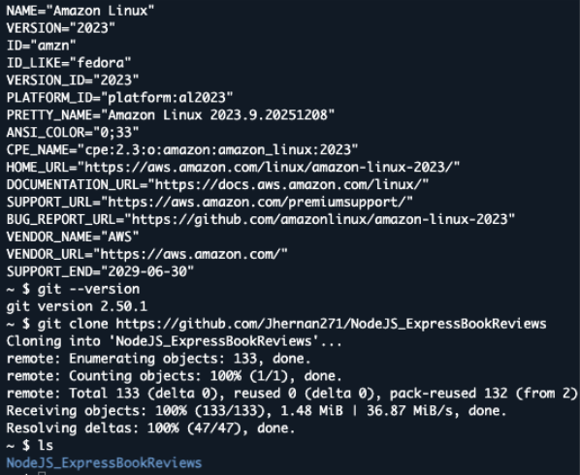
Microsoft Azure Ubuntu VM deployment in the cloud with installed code repository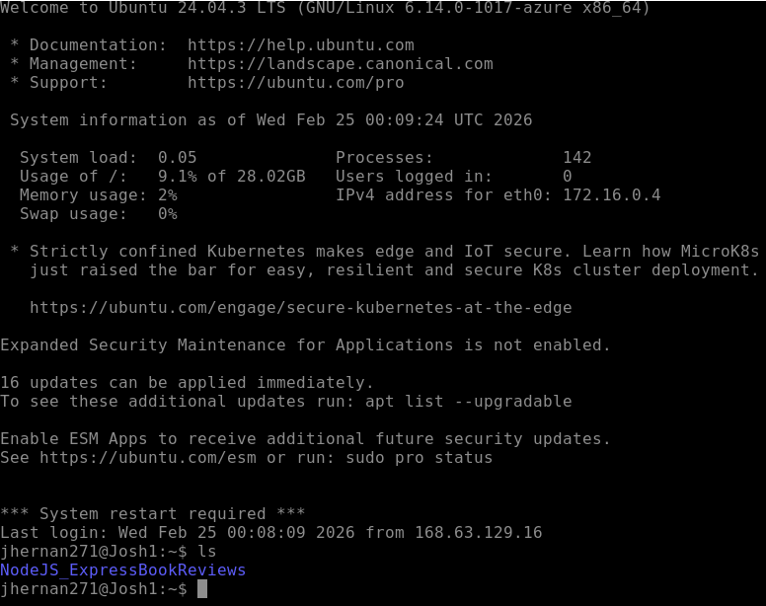
Setup of the Snyk Github integration and code scanning
For the DevSecOps portion of this experiment, a code base with known dependency vulnerabilities in a Node JS project will be uploaded to both the AWS EC2 instance and the virtual machine from Azure. The native ability of each security implementation will be tested to detect the given vulnerabilities present in the codebase residing in the cloud server’s storage. Prior to cloning the code repository from Github into each cloud machine, the documented CWE vulnerabilities are known to the researcher as Snyk has previously been integrated and scanned the existing Github code repository. The primary evaluation purposes of this experiment portion will be to assess each security system’s baseline abilities in detecting vulnerable software without specialized code scanning or extra third-party software installations required to detect security vulnerabilities.
Snyk integration of the Node JS_ExpressBookReviews repository from Github prior to deployment
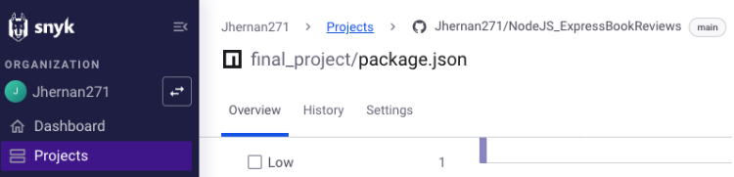
Results and Analysis
AWS GuardDuty and Security Hub assessment results
AWS GuardDuty, the machine learning model, and Security Hub, the centralized cybersecurity dashboard, are two integrated security solutions natively built for AWS cloud systems.
This security system did not trigger any active alerts on the security dashboard from Nmap scanning but was successful in identifying a plethora of internal misconfigurations. From the summary page on the dashboard, one critical threat was identified which was “The API ListManagedNotificationEvents was invoked using root credentials”. This indicates that an API call was made through the machine while operating as the root user; in this instance, the provided public IP address was from the local machine of this researcher.
AWS Security Hub view of the critical threat
Additional insights gathered by AWS Security Hub revealed a tremendous number of vulnerabilities ranging across all levels of severity. Most of the reported vulnerabilities were associated with the Linux kernel utilized by the AWS EC2 instance but also included in the reports were CVE reports on OpenSSL, Python, and the curl command-line tool. The posture management section of Security Hub also revealed some tremendously beneficial reports in highlighting the accessibility of ports 22, 80, 443, and 3389. There were also recommendations to configure log reports and filters to integrate with CloudTrail, the AWS log analysis service within the Posture Management section.
AWS Security Hub vulnerability reports
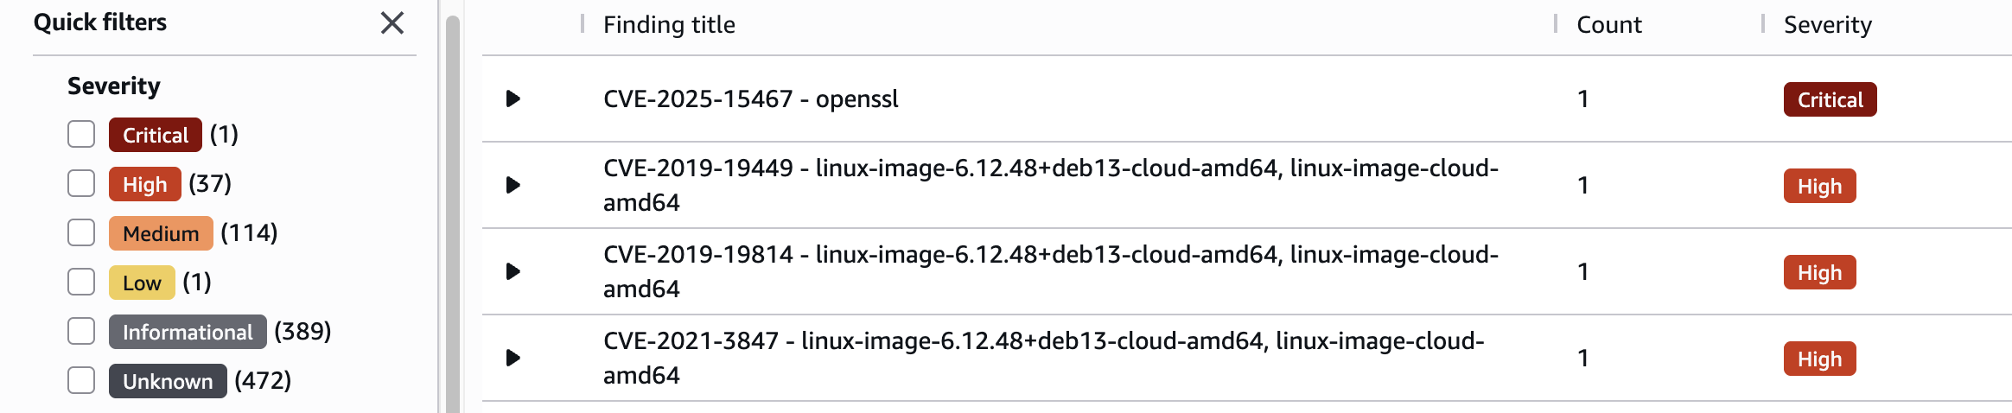AWS Security Hub Posture Management reports
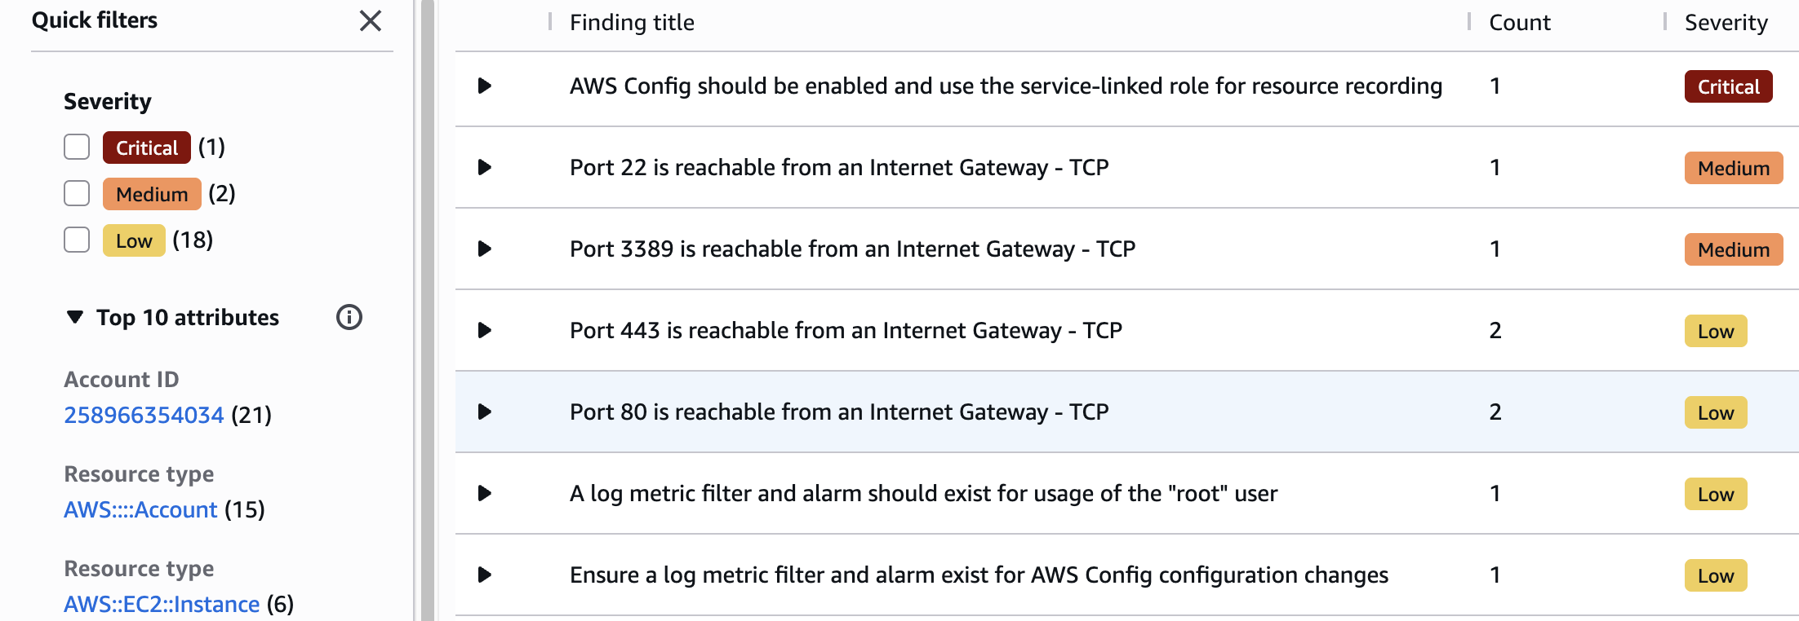Azure Microsoft Defender system assessment results
Like the AWS security systems, Microsoft Defender for Cloud did not detect the vulnerable code base that was previously cloned into the cloud system. Most importantly, Microsoft Defender for Cloud did provide ten security configuration recommendations addressing the open ports present on the machine, enabling encryption on internal disks, setting up a vulnerability assessment solution, checking for system updates, and requiring SSH keys. Defender did not detect any additional high level security threats or posture related recommendations to address in the setup.
Azure security configuration recommendations
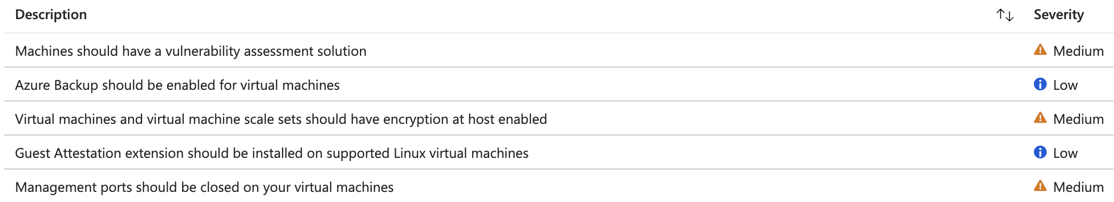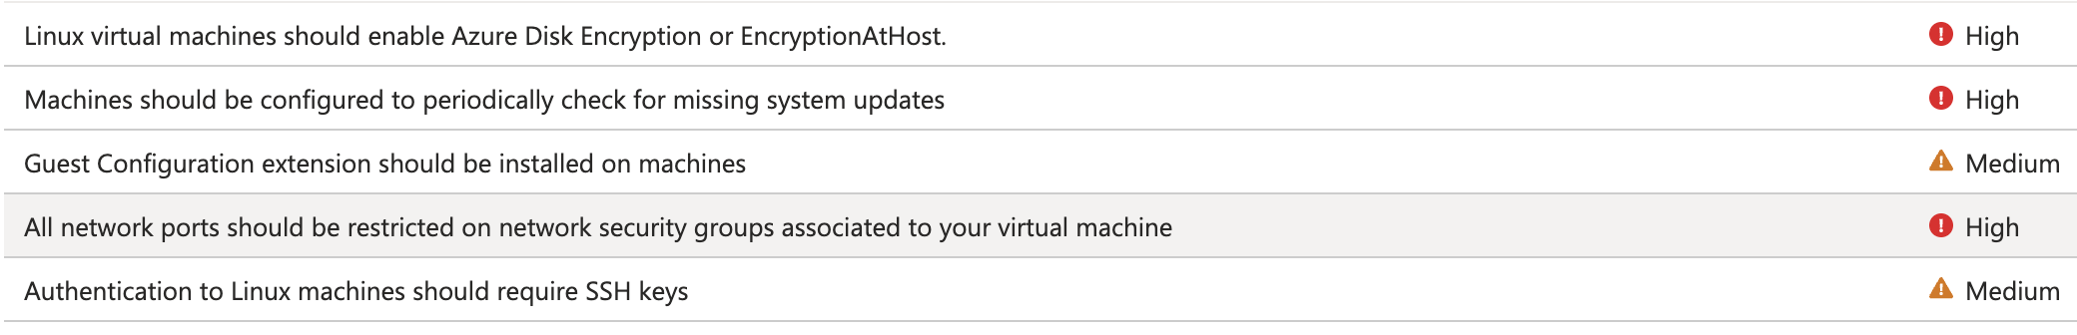Nmap network scanning description
These are the results of the nmap port scan using the default syn scan “-sS” and “nmap -Pn [Ip Address]” commands to identify systems on the network with scans of the 22(SSH), 80(Http), 443(Https) ports respectively for each cloud provider. The only successful scan result in network discovery was utilizing the “Pn” flag to skip host discovery and assume the hosts were online, as this was prior knowledge before the scanning. Previous scan attempts utilizing only the the public IP addresses used to scan were available in the account section for each cloud provider.
Amazon AWS Nmap scan results and outputs in a Mac OS zsh shell
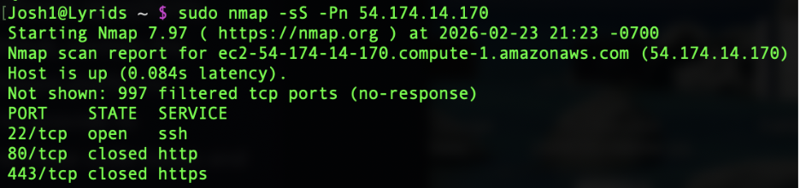Microsoft Azure Nmap scan results and outputs in a Mac OS zsh shell
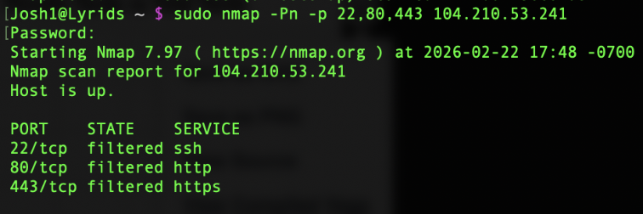
Interpretation and evaluation of the Snyk vulnerability reports
In the following two sections we are going to interpret the Snyk code repository scan results as described by MITRE from the Github integration and NodeJS Book Reviews repository. The first vulnerability reported by Snyk on the NodeJS_ExpressBookReviews code repository “CWE 770-Allocation of Resources Without Limiting or Throttling” defines a scenario where the code base would be susceptible to DDoS-like conditions and attacks where a denial of service could be used to overwhelm and exhaust system resources. This vulnerability can easily be remedied by upgrading the Express web framework middleware to the newest released software version. The second Snyk vulnerability, CWE-1333: Regular Expression Denial of Service (ReDoS), results from outdated project dependencies and can be resolved by updating those dependencies to their current versions.
The third high priority alert identified by Snyk was a collection of three issues including “CWE 327-Use of a Broken or Risky Cryptographic Algorithm”, “CWE 1259-Improper Restriction of Security Token Assignment”, and “CWE 287-Improper Authentication”. All three of these vulnerabilities can easily be remedied by upgrading the Json web token version. The fourth and final vulnerability identified by Snyk was a medium alert “CWE-241-Improper Handling of Unexpected Data Type”. This vulnerability occurs when HTTP response headers can be manipulated by an attacker, which is fixed by simply upgrading the Express session software.

Snyk’s documented descriptions of discovered code vulnerabilities in NodeJS_ExpressBookReviews
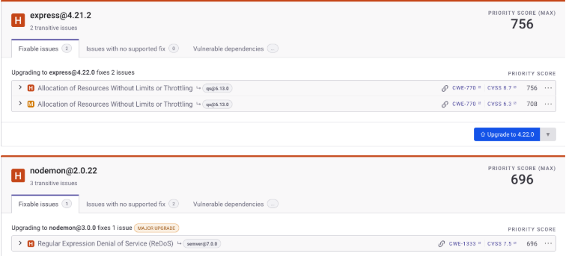
Discussion
A simplified approach was utilized for the purposes of this mini-experiment due to the restrictive subscriptions, availability, and cost of utilizing log analysis and more advanced security services. In a hypothetical enterprise-based environment as a cloud security engineer, the utilization of detailed log analysis through an application such as AWS CloudTrail would have more than likely revealed signature attack patterns from the Nmap scans. It would be imperative to integrate and consistently monitor advanced log analytics as part of a comprehensive security operation. Additional scans not included in this report were an Nmap Christmas scan “sX”, and the sending of malformed data packets to both cloud servers by way of the Python Scapy library. Both additional methods were unsuccessful in triggering system alerts in both AWS and Azure.
The Nmap scans were only minimally successful as they purely discovered the network status of each port, although it did identify an open port 22 to the internet on both servers with a relatively simple scan. The Nmap scans were effective enough in that they did not trigger security alerts in either AWS GuardDuty/Security Hub or Microsoft Defender, but it is enlightening to notate that semi-aggressive Nmap scans did not trigger any security alerts in both security systems, so a security engineer would be wise to implement additional countermeasures to track and detect port scanning. These defensive measures could include tailoring the machine learning models to trigger alerts according to such signature attack patterns and configuring each environment to actively monitor network traffic to the level of effectiveness that a popular and effective network threat detection engine like Suricata provides.
Further recommendations to address the network reconnaissance security gap
As evidenced by the limitations of the built-in security services to detect network scans, we can implement machine learning based SaaS applications more directly capable of recognizing active attack patterns. Fortinet has developed a traffic collection application called FortiNDR that is capable of cloud native AI-driven threat detection available on both AWS and Azure that can primarily recognize behaviors like port scans, lateral movement, and anomalous traffic patterns. Fortinet (2026) describes FortiNDR as being able to detect encrypted attacks and malicious files through neural network analysis, detect network anomalies, analyze malware scientifically, trace the source of malware events and worms, and upon recognizing anomalous events perform automatic mitigation procedures. This robust third-party security integration would be a more specialized security add-on to strengthen each cloud systems ability to detect all levels of network scans, active reconnaissance, and malware-based attacks. A security engineer could additionally utilize each cloud providers marketplace offerings to tailor and locate any additional dedicated third-party network threat detection engine that best suits the application needs of their cloud infrastructure.
The most positive development and key takeaways of both security implementations were their abilities to provide valuable security recommendations on vulnerabilities and misconfigurations on the internal network. AWS Security Hub provided close to a thousand vulnerability reports that would require further investigation and refinement of the cloud infrastructure. Azure provided some meaningful recommendations as well, but not as readily informative as the AWS security architecture. A beginning cloud development team would be well suited to familiarize themselves well with the security system documentation to customize their configurations according to the build structure of the code base and network. Particularly, the AWS reports highlight the extensiveness and volume of potential security misconfigurations and vulnerabilities that are present in a cloud-based system.
The Snyk Github integration and vulnerable code base portion of this experiment illustrated a key consideration. Software developers should consistently apply secure software development lifecycle principles and incorporate them into a broader DevSecOps philosophy. This would be evident by a developer regularly scanning the code base for potential problems early in the software development lifecycle and certainly before deployment to any cloud service. As evidenced by the Snyk vulnerability scan results, dependency misconfigurations and outdated software often lead to critical security weaknesses that can be exploited by an attacker. A general recommendation to overcome the shortcomings of the AI-driven security systems in these experimental procedures would be to install the command line interface version of Snyk to more directly scan the code repository available in the cloud system storage.
Conclusion and Future Implications
Cloud-based AI security solutions provide a path for a prosperous and responsible technological future that ensures the reliability and robustness of security architectures. AI‑powered security solutions enable security teams to strengthen their incident response capabilities and stay aware of emerging threats. They also help organizations prepare for increasingly sophisticated attacks, including those driven by advanced AI-enabled methods and the potential looming threat of quantum computing. AI‑powered cloud security models contribute to a safer and more resilient digital landscape, offering society a blueprint for a secure technological future. By enabling faster threat detection, adaptive defense mechanisms, and scalable protection across complex network infrastructures, these systems help organizations meet the evolving demands of modern industry.
Amazon AWS and Microsoft Azure are incredibly well-equipped cloud platforms that offer an inclusive all-in-one marketplace to integrate software and security needs in one singular location. Security engineers and developers from a startup software company or beginning enterprise application would be wise to develop a consistent and ongoing company training program that involves a review of procedures, incident response, setup, and review of platform documentation to integrate all working systems together within the cloud. In this experiment, a significant amount of time was spent configuring security integrations, reviewing documentation, and navigating various software applications to arrive at the operational ability to test each provider. Without prior cloud security experience or the willingness to learn and practice secure cloud development principles, one can see how companies can easily overlook security implementations for the sake of rushing their products to market.
As evidenced by the ease at which vulnerable code was deployed into the cloud environments without native detection by the security systems, secure coding practices adopted by a DevSecOps philosophy should be a prerequisite requirement for enterprise applications. Given the highly interconnected nature of cloud-based environments and the need for integration of multiple systems in some applications, software security becomes of paramount importance. A single-entry point into a cloud-based system potentially offers an attacker the opportunity to move laterally throughout the system without the proper segmenting or zero-trust implementation of the security architecture.
Looking ahead, the successful integration of AI-powered security solutions, DevSecOps principles, and the continuous evolution of cloud security monitoring will become essential for developing resilience in cloud-based systems. Organizations must be proactive and disciplined in their approaches and adapt to the constantly changing technological landscape. The complexity of modern-day distributed systems, such as a cloud environment, demands that engineers and practitioners be attentive to details and are constantly seeking to learn and apply new knowledge as the industry evolves. Cloud computing has changed the fundamental reality of system scalability, connectivity, and security. As a result of the highly connected nature of cloud systems, small oversights can have devastating and far-reaching consequences. As organizations and technology infrastructures continue to migrate critical workloads into these digital ecosystems, the responsibility to design and maintain secure systems becomes not just a technical requirement but an operational imperative to secure our technological future.
References
Abdul, S., Ismail, B. I., Khan, S. M., Sattar, S. A., & Muhammad, S. (2023). Assessing AI-based threat detection in cloud security. Available at SSRN 5477111.
Ahmadi, S. (2024). Zero trust architecture in cloud networks: Application, challenges and future opportunities. Ahmadi, S. (2024). Zero Trust Architecture in Cloud Networks: Application, Challenges and Future Opportunities. Journal of Engineering Research and Reports, 26(2), 215-228.
Ali, A. M. (2025). Best Practices for Configuring and Optimizing Virtual Machines in Microsoft Azure. IJSAT-International Journal on Science and Technology, 16(2).
Anupam, A., Gonchigar, P., Sharma, S., SB, P., & MR, A. (2020). Analysis of open source node.js vulnerability scanners. International Research Journal of Engineering and Technology (IRJET) e-ISSN, 2395-0056.
Bisong, A., & Rahman, M. (2011). An overview of the security concerns in enterprise cloud computing. arXiv preprint arXiv:1101.5613.
Fortinet. (n2026). Introduction: FortiNDR on Azure (Version 7.6.0). https://docs.fortinet.com/document/fortindr-public-cloud/7.6.0/fortindr-on-azure/385967/introduction
Kaur, G., & Kaur, N. (2017). Penetration testing–reconnaissance with NMAP tool. International Journal of Advanced Research in Computer Science, 8(3), 844-846.
Naseer, I. (2023). AWS cloud computing solutions: optimizing implementation for businesses. Statistics, computing and interdisciplinary research, 5(2), 121-132.
Oprişa, C., Grigoruţ, D. O., Mouratidis, H., Lakka, E., Manta, O., Mavrias, A., ... & Ioannidis, S. (2026). A large-scale analysis of code security in public repositories: C. Oprişa et al. International Journal of Information Security, 25(1), 24.

